Big Exam! #3, Physics 141 Schwartz, S16, Name________________ Communication of Physics
No Calculators and No Trig allowed today
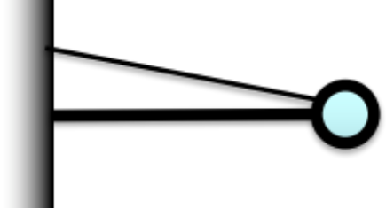
- A 100 kg sphere is hung in front of a store (as an advertisement for ball bearings) using a very light (carbon fiber) bar and a thin cable as shown at right. The linkage between the bar and wall is a freely rotating hinge (shown below) so that without the cable, the ball would swing downward with no friction. BUT, the cable keeps it hanging there.

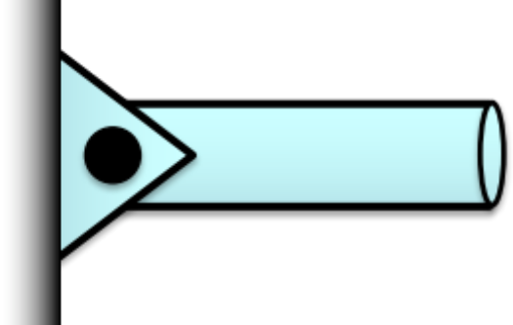
- Is the tension in the cable more, less, or equal to the force of gravity on the ball? How do you know?
- Is the bar pushing on the ball or pulling on the ball? How do you know?
- Estimate the tension on the cable.
- Estimate the force the hinge puts on the bar at the store front (include direction).
Note that this is different from the problem set problem. Note that the angles are different
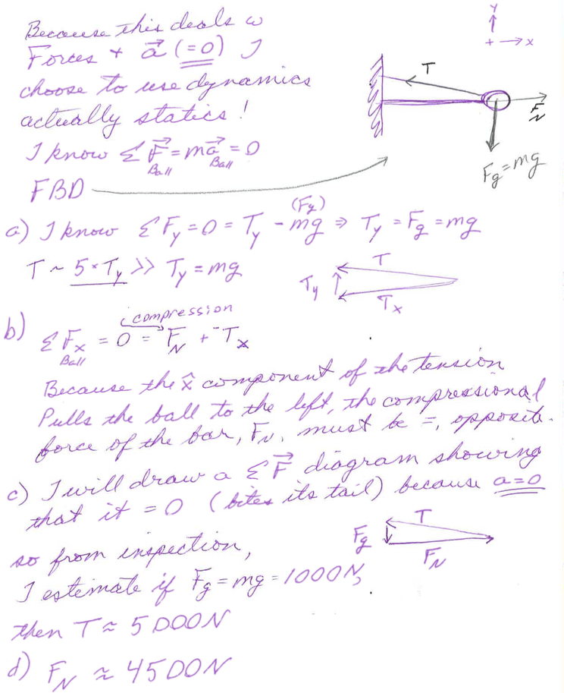

- You’re at a new kind of tanning salon where there is a massive ultraviolet bulb in the middle of a room and the people (with sun glasses on) just hang around where they like to get tan. You’re standing at a distance of 4 meters from the spherical bulb and notice that you’re getting “done” a little too fast, so you ask them to cut the power to the bulb to ¼ of the present power, but they won’t change it. You decide to move. About how far away from the bulb should you stand if you want ¼ the present intensity? Provide a good explanation supporting your new distance and why this is the correct distance.


