Problem Set #4 Solutions
- MT#1 Solutions – Hand in Tuesday. Solutions will be posted on the main webpage under tests.

- My daughter is sledding (total mass = 20 kg), and I am applying a force of 120 N to her sled. I have 4 different options (pushing and pulling at two different angles) and I try all of them.
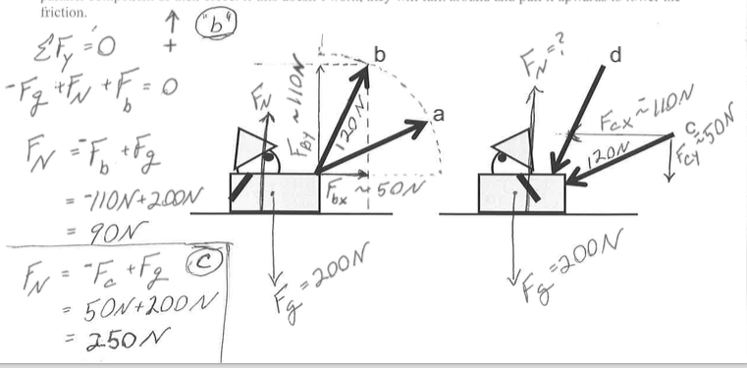
- For each scenario, estimate both the acceleration of the sled and the normal force between the sled and the frictionless snow. This is a dynamics problem because I see there are forces and acceleration involved. It’s crucially important here to separate the problem into the x and y components. Using no trigonometry, I’m estimating the components of the tension.
POOP! I don’t know anything. WAIT, I know that the vector sum of the forces = ma. So I draw the force diagram (right) and ask if it’s in equilibrium: NO, it’s accelerating to the right… horizontally. I immediately know that I have to have an x – y coordinate system, and the sum of the y forces = zero, the sum of the x forces = ma_{x}. Above, I show how I estimate the components of the forces for b and c. Then I calculate the normal forces for b and c. Show the normal forces for abcd are 150N, 90N, 250N, 310N, respectively.
- Now, please rank the different force scenarios in order of least acceleration to greatest acceleration. If some accelerations are the same, please indicate that. Because there’s no friction, the normal force doesn’t matter and I’m just looking at the forces in the x-component for the problem. There is only 1 force: the x component of the force. To find acceleration, just divide by the 20 kg mass. F_{xa} =F_{xc} > F_{xb} =F_{xd} so the accelerations in increasing order are: b=d ~ 2.5 m/s < c=a ~ 5.5 m/s
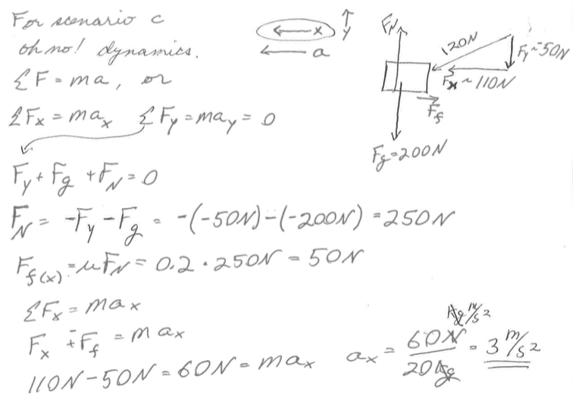
- Now, let’s say that the coefficient of friction of the snow is actually 0.2. How does this change things? Please rank again the different force scenarios in order of least acceleration to greatest acceleration. Now that there’s friction, I know that I have to include an additional frictional force, and because d and c have me pushing downward, they will have a higher normal force to be in equilibrium in the y direction, and thus a higher frictional force than a and b. Additionally d has a higher vertical component of compression than c because it is coming at a higher angle. So the order of increasing frictional force slowing us down is b < a < c < d. So clearly scenario “a” will accelerate faster than c; and b will accelerate faster than d. However, it’s not clear until we do the math if a or b has higher acceleration, but d definitely has the lowest acceleration because it has the highest frictional force and the lower parallel force. The approximate accelerations I get are respectively for abcd: 4 m/s², 1.6 m/s², 3 m/s², - 0.6 m/s², because F_{x} < F_{friction.} See at right the calculation for scenario “c”. Please repeat this for the other scenarios and make sure your answers make sense.
d) Have you ever pushed a lawn mower (or watched someone do it)… you are using force scenario d, pushing along the handle. When you run into some thick grass the “coefficient of friction” might be high enough to stop you cold. What scenario can you change to, and why does this work? From the above arguments and calculations, you should be able to watch someone pushing a lawn more: They start comfortably walking pushing as d. When they hit some thick grass, they will go down to c, lowering the friction and increasing the parallel component of their force. If this doesn’t work, they will turn around and pull it upwards to lower the friction.

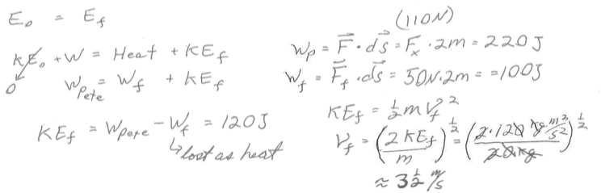
- Consider pushing the sled above in scenario “c” on the 0.2 frictional snow for a total of four meters, please find the amount of work I do, the amount of heat produced and the final speed of the sled. Carefully lay out your lens discussion. I use an energy lens because I’m looking at work that I do goes to increase kinetic energy and heat (the work of friction =~ 100 J).

- Consider throwing a rock from the edge of a 60 m high cliff at a speed of 30 m/s in the direction indicated by force vector “b” above.
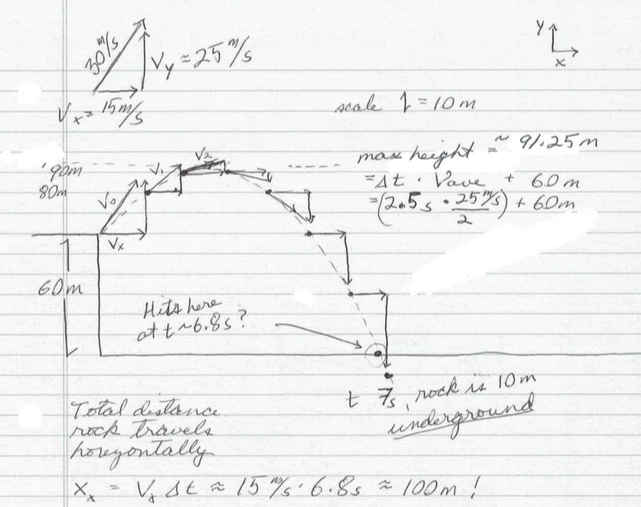
- Please make a drawing showing the rock at each second until it hits the ground. You may not use a calculator, as we are making simple approximations here. For each second elapsed, estimate where the rock is and its velocity. Draw the velocity vector at that point. This is straight up kinematics – displacement, velocity changes over time (and the explicit reference to time is a strong indicator that this is kinematics). I’m estimating that 30 m/s at this angle corresponds to about v_{x} = ~ 15 m/s, and v_{y} = ~ 25 m/s. We know that the acceleration is only in the y direction (~ - 10 m/s²), so that v_{x} will not change, and v_{y} will be 15 m/s after 1 second, 5 m/s after 2 seconds… etc. ALSO, we know that the average speed for the first second will be 20 m/s (half way between 25 m/s and 15 m/s) so it will move 20 m upward in the first second); and for the 2nd second, the average speed will be 10 m/s, and during the 3rd second it will turn around and have an average velocity of 0… etc. All the while, the rock will move 15 m further in the x direction each second.
- Use an energy lens to judge if your final speed is reasonably close to what you would expect. Here we use an energy lens because the final kinetic energy is the sum of the initial kinetic energy + the potential energy that the rock lost. According to my drawing, the final speed would be 15 m/s x and in the y direction, a little less than 45 m/s … with a total speed of about 45 m/s corresponding to kinetic energy of about 1000 J for a 1 kg rock. How does this compare to the initial energy? Please show that a 1 kg rock with v=30 m/s has 450 J of kinetic energy, and at an elevation of 60 m, has 600 J of kinetic energy for a total mechanical energy of 1050 J. We can see that my estimates are reasonable: The final kinetic energy ~ total initial mechanical energy. Please repeat this calculation.

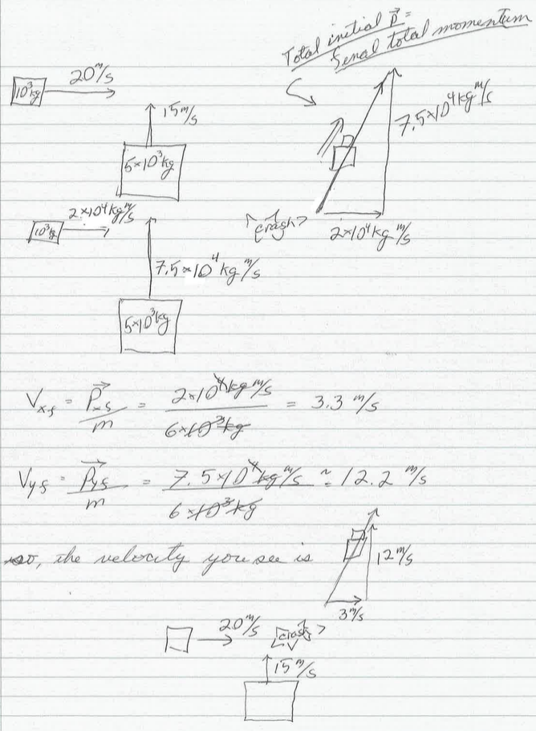
- On a surface of frictionless ice, a 1000 kg car driving 20 m/s eastward collides and sticks to a 5000 kg truck driving 15 m/s northward. The vehicles stick together and slide:
- Please draw and indicate the final velocity of the vehicles. This is clearly a momentum problem because we have an inelastic collision, so the only thing we know is that momentum is conserved… remember that momentum is a vector. A velocity diagram won’t do us much good because velocity isn’t conserved, so I immediately draw a momentum diagram (in the middle at right). Then, conserving momentum, I can find the final momentum. I find the final velocity by dividing the final momentum by the total mass of the two vehicles stuck together.
- Please calculate the amount of energy turned to heat in the collision.

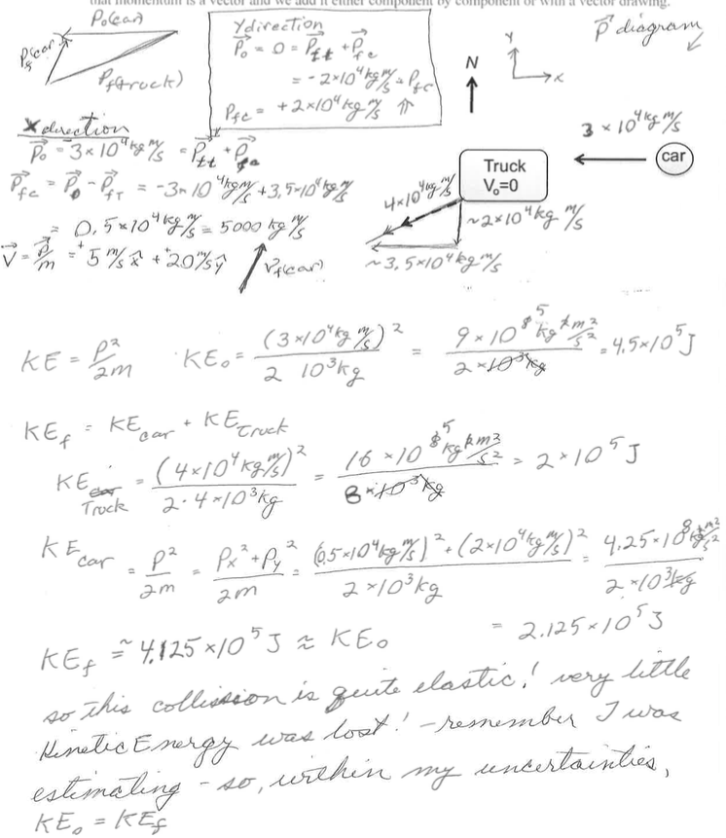
- On a surface of frictionless ice, a 1000 kg car driving 30 m/s westward collides with a 4000 kg truck at rest. The truck subsequently takes off at 10 m/s in the direction indicated. North is indicated
- Without using a calculator, please determine as best you can the subsequent velocity of the car. In any collision, the only thing we know is that momentum is conserved, so we make sure we know that momentum is a vector and we add it either component by component or with a vector drawing.

- Was mechanical energy conserved in this collision? This is an energy problem, we just compare initial kinetic energy with final kinetic energy.

At right, you see two pictures of me at 70 kg, slack lining.
- In which drawing is the line tighter? This is a dynamics problem… in particular a statics problem because there is no acceleration. We look at the forces on the man at rest and we add them like vectors to sum to zero. The x components of the tension cancel each other, and the y components add to be equal and opposite to gravity (because we’re in equilibrium). On the left the ratio of the horizontal and vertical components is about 5:1, on the right, it’s more like 10:1. So, if the force of gravity on the man is 700N, then the tension on the right would be about 3,500 N, and on the left would be about half that.
- Using your force drawing, please estimate the tension on the slack line at right. See below.
- In a classic physics problem, a car is stuck in the mud, so you tie a rope to a tree on the other side of the road as tight as you can and then push the rope – do you pull it along the rope, or push it perpendicular? Would it be a good idea to slack line on it? If you were slack lining on it, would it be a good idea to jump on it? We just showed that if you push perpendicular to the rope, the tension will be greater than the perpendicular force you apply…. As long as the rope is inelastic enough to not deflect to high angles… That is, for the slackliner example, please show that if the slack line made an angle of 30 degrees with the horizon, that the tension would be the same as the force of gravity on the man. If you bounced on the slackline, then at the bottom of your oscillations, you would be accelerating upward, and thus the tension in the slackline would be greater than the force of gravity.


