Problem Set #8 due beginning of class, Monday, November 16

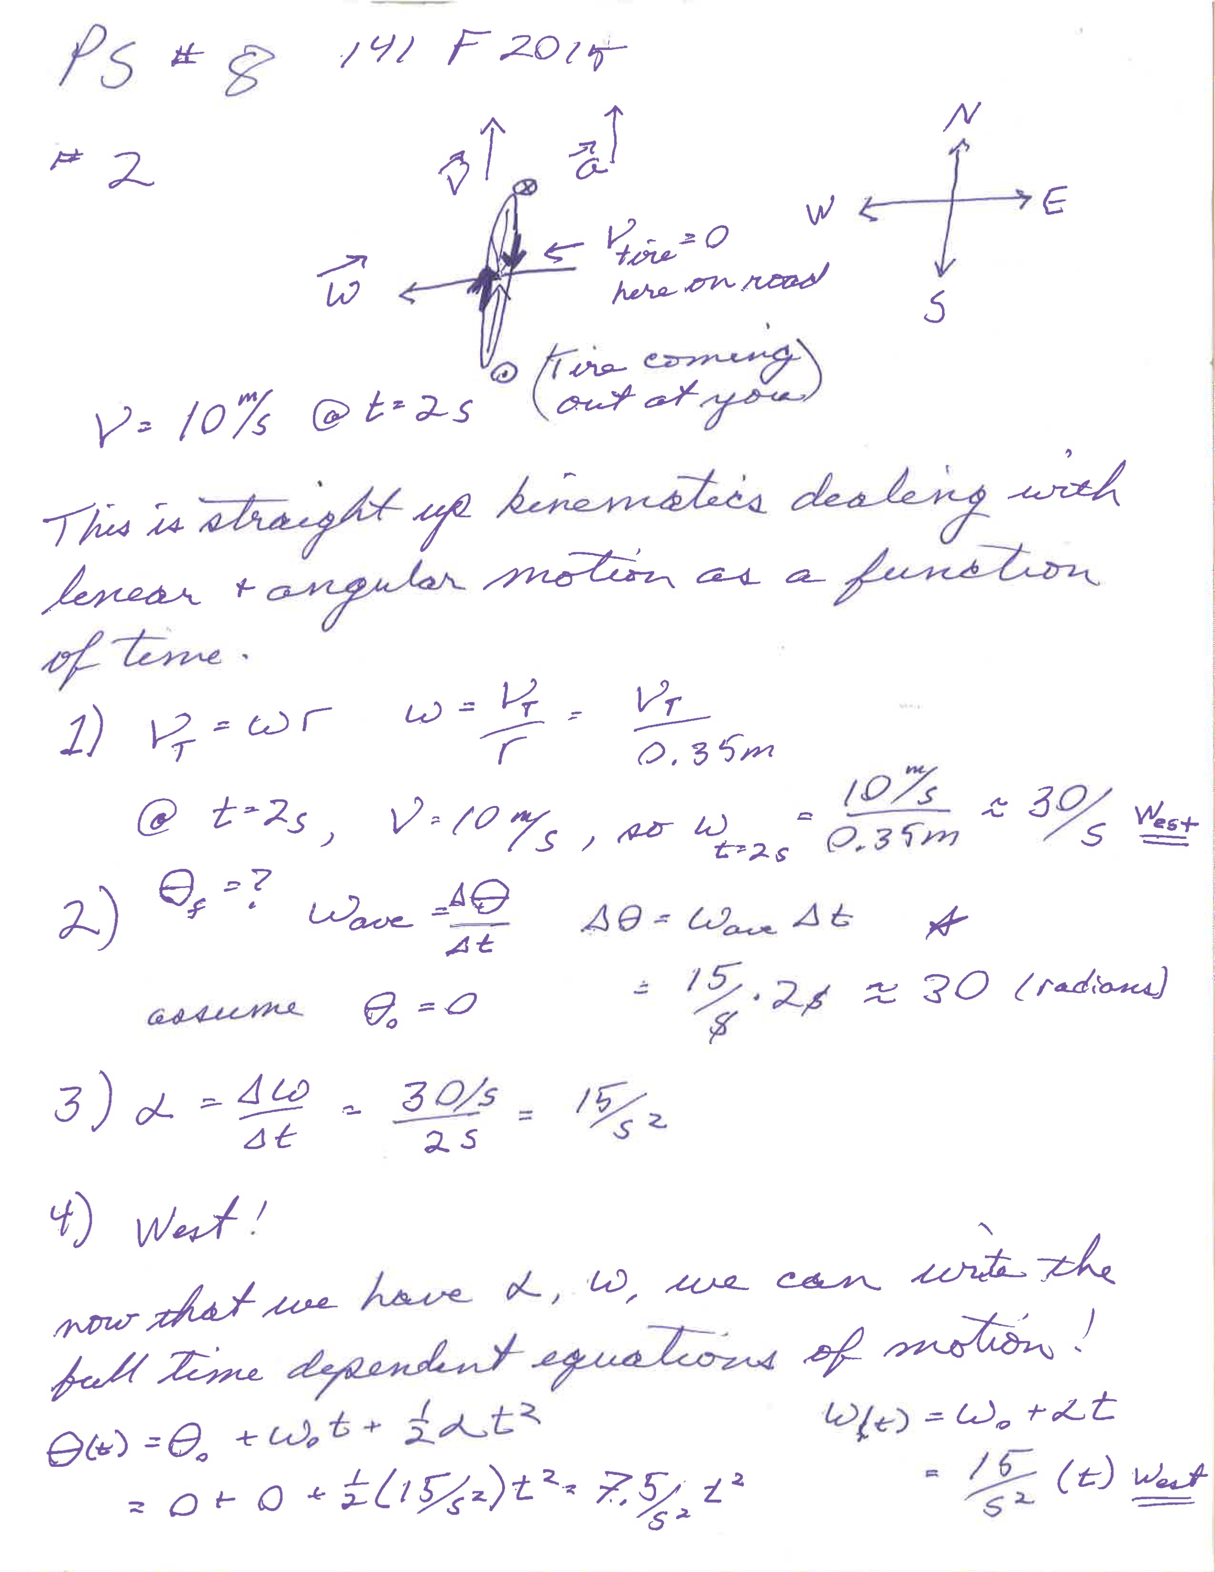
#1 MT#2 solutions are posted separately on the main webpage under tests.

#3, Please do both problems below
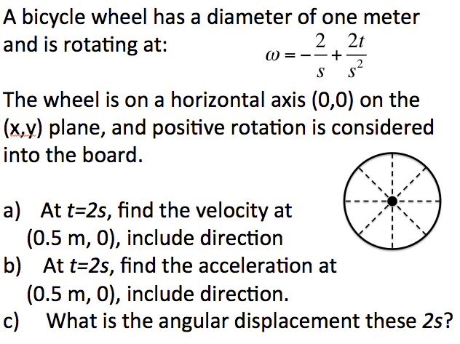
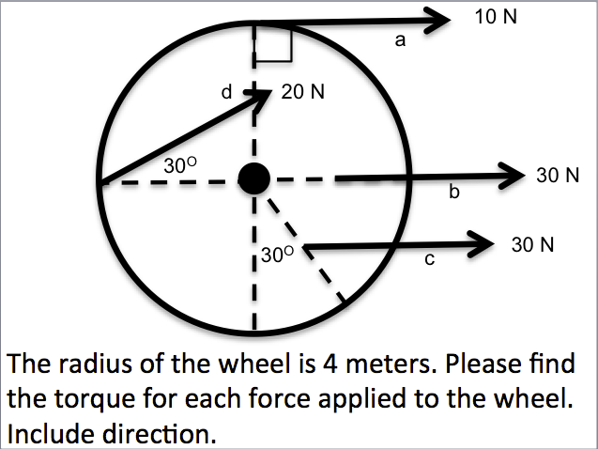

****on the left*****
We have forces and distances and want to calculate torque. This is a rotational dynamics problem, but more explicitly, it is just a calculation of torque = r x F , representing a vector cross product.
- F is perpendicular to r, so the cross product collapses to a simple product of 40 N*m into the board (Remember to use your right hand to verify this), as there is no motion, N*m is NOT a Joule.
- Because there is no perpendicular component, this cross product yields a torque of zero, which we can see will not compel the wheel to turn.
- Here, we need to take the perpendicular component of the force… or the radius. We recognize that the angle between the radius and the force is 120 degrees, not 30 degrees, and the force is applied at a radius of 2 m, not 4 meters. The perpendicular component of the radius is ~1.74 m. You can see this if you extend the force vector backwards until it encounters the vertical dotted line. So the torque is about 52 Nm out of the board
- I would decompose the force into parallel and perpendicular components. The perpendicular component is 10 N yielding a torque of 40 Nm into the board.

*******on the right******
Let’s look at the wheel and imagine this happening in our mind. The wheel starts with negative rotation (counter clockwise) of 2 radians/s, or it takes ~ 3 seconds to turn around once, however the angular acceleration is positive, so the wheel slows to a stop after one second and thereafter begins spinning clockwise with ever increasing angular velocity.
- At t=2s, the speed of the rim is ω x r = 0. It is also the speed in the middle of the spoke as indicated by a radius of 0.5 m. ω = +2/s at this time, so the speed is 1 m/s and we can see from the picture that the direction of the velocity is downward, or v = - 1 m/s y
- The tangential acceleration is a_{tangential} = α x r but because α is perpendicular to r this is just a product, so the tangential acceleration is a_{tangential} = - 1 m/²s y HOWEVER, there is also centripetal acceleration because we have circular motion… the point is being accelerated into the center of the circle or in the –x direction. a_{centripetal} = ω²r, please prove this to yourself. Or a_{centripetal} = - 2 m/²s x .
So, a = - 2 m/²s x - 1 m/²s y

#4, #5, #6, #7 #8 were questions 1-5 for PS#7 Winter, 2015, and can be found here: PS#7 Solutions Q1-4, and PS#7 solution Q5

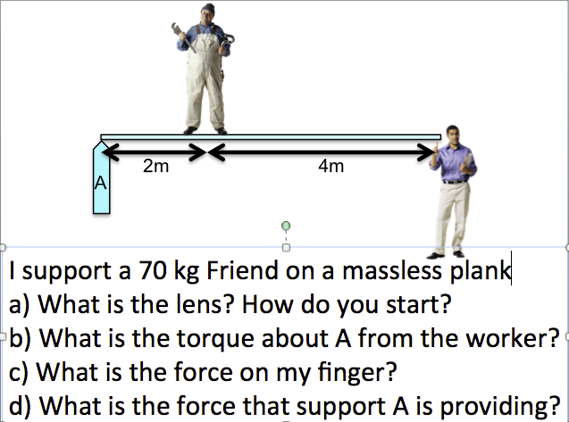
#9 Because we’re dealing with forces, torques and accelerations, this is a dynamics problem. More explicitly, we hope that this is a statics problem because we would like acceleration to be zero. If this system is at rest, we know both the rotational and the linear accelerations are zero! Therefore, we know the vector sums of the forces = 0 and the vector sums of the torques = 0. This gives us two equations to solve for the two unknown forces (reactive force at A, and the force on my finger. We know we can choose any point to be the center of rotation, so we pick one of the points with unknown forces, so that when we solve the torque equation, that unknown force drops out of the equation, and we can solve for the other unknown force! Let’s choose point A. Let’s solve for the sum of the torques and define positive torque as into the board Torque A is zero about this point. The torque due to the force of gravity on my friend is 1400 Nm in the positive direction, so I must apply a torque of – 1400 Nm. At a radius of 6 m, the force of my finger on the plank (= the force of the plank on my finger) must be about 233 N… or about 50 lbs… could I do this? You decide! Now we can balance forces if we like, or balance the torques about another point to find the reaction force about A. My friend puts a downward force of 700 N on the system and I put an upward force of 233 N, so F_{A} = the difference, or ~ 467N y, I’m glad that force isn’t on my finger… good thing I chose the other side. You can also see that if we take the rotation point as where my friend is, I’m twice the distance as A, so the force I need to apply is half that of F_{A.} Hey, please let me know if I did this correctly.

